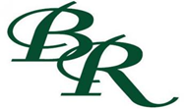
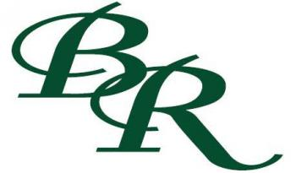
2016 Blue Ridge High School Baseball Schedule
Date Time Day Location
2/12 4:30 Friday @Tom Bean (Scrimmage)
2/19 5:30 Friday @Bells (Scrimmage)
2/25 - 2/27 TBA Thurs-Sat @Pottsboro Tournament
3/1 6:30 Tuesday @Bonham (JV)
3/3 - 3/5 TBA Thurs-Sat Blue Ridge Tournament
*3/8 2:00 Tuesday @Dodd City
3/10 – 3/12 TBA Thurs-Sat @Leonard Tournament
3/10 – 3/12 TBA Thurs-Sat @Lone Oak Tournament (JV)
*3/15 4:30/6:30 Tuesday Trenton (Has a JV team)
3/19 Noon Saturday @Farmersville (JV)
3/21 4:30 Monday @Bland (JV)
*3/22 4:30 Tuesday @Bland
*3/25 6:30 Friday Celeste
*3/29 4:30 Tuesday @Wolfe City
3/31 5:30 Thursday Bells (JV)
*4/2 4:30 Saturday @Honey Grove
*4/5 6:30 Tuesday Dodd City
*4/8 6:30 Friday @Trenton (JV not playing this date)
*4/12 4:30/6:30 Tuesday Bland (Has a JV)
*4/15 6:30 Friday @Celeste
4/18 4:30 and 6:30 Monday Princeton (JV double header 5 inning games)
*4/19 6:30 Tuesday Honey Grove
*4/22 6:30 Friday Wolfe City (Senior Night)
Head Coach: Pete Vamvakas Assistant Coach: Daniel England
Athletic Director: Kevin Wiggins Superintendent: Todd Lintzen
High School Principal: Anthony Figueroa *District Games Bold and Italicized*

