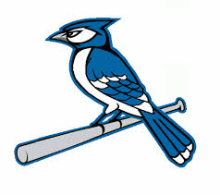2018 Snook Bluejays Baseball Schedule
Date Opponent Site Time
Feb. 15 Normangee (Scr) Snook 4:30
Feb. 20 Granger Granger 5:00
Feb 23 North Zulch North Zulch 4:30
Feb. 27 Normangee Snook 6:00
Mar. 1 – 3 Snook Tournament Snook TBA
Mar. 5 Texas Wind Waco 4:00
Mar. 8 – 10 Thrall Tournament Thrall TBA
Mar. 15 Bartlett Bartlett 3:00
Mar. 20 Somerville Somerville 6:30
Mar. 23 Mumford Mumford 5:00
Mar. 27 RTC Snook 6:00
Mar. 29 Burton Snook 6:00
Apr. 3 Iola Snook 6:00
Apr. 6 Somerville Snook 6:00
Apr. 10 Mumford (SR Night) Snook 6:00
Apr. 13 RTC RTC 4:00
Apr. 17 Burton Burton 6:30
Apr. 20 Iola Iola 7:30

Head Coach – Kevin Macik Superintendent – Brenda Krchnak
Assistant Coach – Brian Paul Principal – Dr. Kenzie Bond
Athletic Director – Chad Lechler Assistant Principal – Megan Brock

