Date | Opponent | Location | Time
February 6 | Arlington Newman** | Cedar Hill | 4:00pm
February 13 | Valley Mills** | Milford | 4:30pm
February 17 | Blooming Grove** | Blooming Grove | 5:00pm
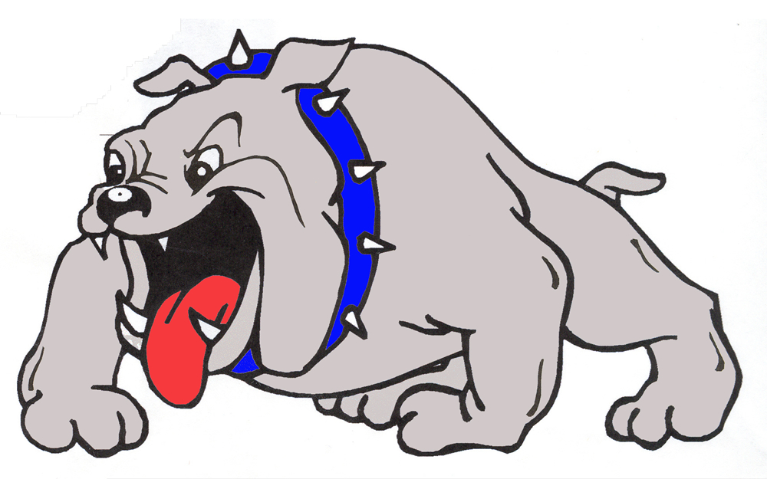  February 21 | Hico | Hico | 4:30pm
February 24 | Riesel | Riesel | 6:00pm
February 28 | Bye
March 2-4 | Avalon/Blooming Grove Tournament | Avalon/Blooming Grove | TBD
March 7 | Abbott* | Milford | 4:30pm
March 10 | Snook | Milford | 4:30pm
March 14 | Italy* | Italy | 4:30pm
March 17 | Avalon* | Avalon | 4:30pm
March 21 | Itasca* | Milford | 4:30pm
March 24 | Blum* | Blum | 4:30pm
March 28 | Frost* | Milford | 4:30pm
March 31 | Covington* | Covington | 4:30pm
April 4 | Abbott* | Abbott | 4:30pm
April 7 | Italy* | Milford | 4:30pm
April 11 | Avalon* | Milford | 4:30pm
April 13 | Itasca* | Itasca | 4:30pm
April 18 | Blum* | Milford | 4:30pm
April 21 | Frost* | Frost | 4:30pm
April 25 | Covington* | Milford (S) | 4:30pm
Home games in Bold **=Scrimmage *=District 16AA Game (S)=Senior Night
Head Coach: | Chris Moore
Assistant Coach: | Rolando Vega
Athletic Director: | Otis Carter
Superintendent: | Don Clingenpeel

