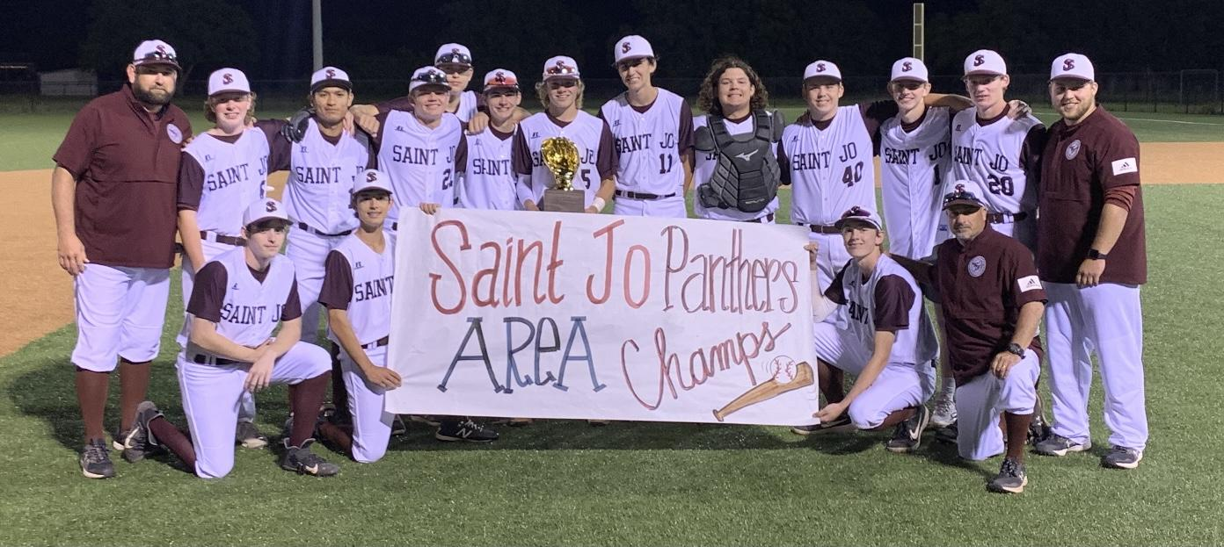

Date | Opponent | Place | Day | Time
February 10 | Tioga (Scrimmage) | Tioga | Thursday | 4:00
February 17 | Era (Scrimmage) | Era | Thursday | 4:00
February 26 | St Jo (Doubleheader) | St Jo | Saturday | 10 & 12 & 2
March 1 | Era | St Jo | Tuesday | 5:00
March 3-5 | Era Tournament | Era | Thursday-Saturday | TBA
March 8 | Lindsay | Lindsay | Tuesday | 6:30
March 10-12 | St Jo Tounament | St Jo | Thursday-Saturday | TBA
March 15 | Lindsay | St Jo | Tuesday | 6:30
March 18 | Clayton OK | St Jo | Friday | 10:00 AM
March 22 | Open
March 24-26 | Diamond on the Red Tournament | Thackerville | Thursday-Saturday | TBA
March 29 | Poolville | St Jo | Tuesday | 6:30
April 1 | Poolville | Poolville | Friday | 6:30
April 5 | Perrin | St Jo | Tuesday | 6:30
April 8 | Perrin | Perrin | Friday | 6:30
April 12 | Muenster | St Jo | Tuesday | 6:30
April 15 | Muenster | Muenster | Friday | 6:30
April 19 | Alvord | Alvord | Tuesday | 6:30
April 22 | Alvord | St Jo | Friday | 6:30
April 26 | Chico | Chico | Tuesday | 6:30
April 29 | Chico | St Jo | Friday | 6:30

