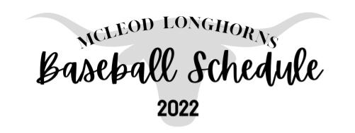

Date Opponent/Location Time

Feb 24-26 James Bowie Tour. TBA
Mar 3-5 New Boston Tour. TBA
Mar 10-12 Hughes Springs Tour. TBA
March 15 @Detroit 4:30
March 18 VS Rivercrest 6:00
March 22 @ Maud 6:00
March 25 VS Avinger 6:00
March 29 @ L-K 5:00
April 1 @ James Bowie 6:00
April 5 VS Avery 6:00
April 8 VS Detroit 4:30
April 12 @ Rivercrest 6:00
April 14 VS Maud 6:00
April 19 @ Avinger 4:30
April 22 VS L-K 6:00
April 26 VS James Bowie 6:00
April 29 @ Avery 4:30

Head Coach: Spud Adams Athletic Director: Steven Lambeth
Assistant Coach: Jared Vick Superintendent: Cathy May

