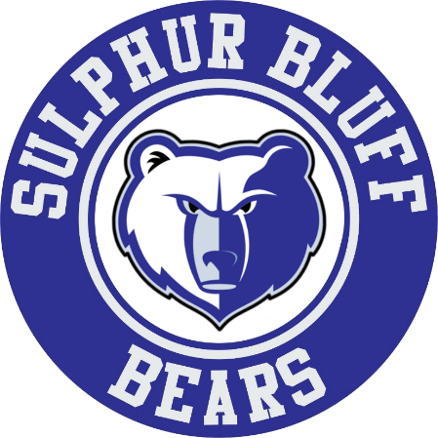

2nd Annual
Sulphur Bluff Bears Baseball Tournament

Sulphur Bluff Baseball Tournament Information
Hello Coaches,
Thanks for coming to the SBISD Tournament. We should have some good competitive ballgames and get a lot of playing time for our kids. Just to be on the safe side again this year, we will keep team interactions to a minimum by playing a doubleheader each day and keep it to a two-day tournament. If anybody would like to play another game on Saturday, let me know and I bet we can make it happen.
Cost is $325 and a dozen baseballs.
We will go with a 1 hour and 30 minute time limit, coin flip at the plate for Home/Visitor, take the available dugout based on the schedule. We will have cages available for warmups before games at our softball field. A concession stand will be on site, let me know if you plan to feed your kids and we will make sure we have enough hamburgers and fries for them. We will have a $6 dollar meal deal for planning purposes.

Thursday, March 3
11:00 – 12:30 Sulphur Bluff vs Union Hill
12:45-2:15 Miller Grove vs Union Hill
2:30 – 4:00 Miller Grove vs Harts Bluff
4:15- 5:45 Avery vs Harts Bluff
6:00-7:30 Avery vs Sulphur Bluff

Friday, March 4
11:00 – 12:30 Sulphur Bluff vs Miller Grove
12:45-2:15 Avery vs Miller Grove
2:30 – 4:00 Avery vs Union Hill
4:15- 5:45 Harts Bluff vs Union Hill
6:00-7:30 Harts Bluff vs Sulphur Bluff

