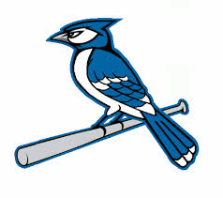
2019 Snook Blue Jays Baseball Schedule
Date Opponent Site Time
Feb. 7 Open
Feb. 14 Open
Feb. 19 (T) St. Joes Snook 5:00 (BB – 1st Rd.)
Feb. 21(Th) North Zulch Snook 5:30 (BB – 2nd Rd.)
Feb. 26 (T) Normangee Snook 5:30 (BB – 3rd Rd.)
Feb 28, March 1–2 Snook Tournament Snook TBA
Mar. 5 (T) Mumford* Snook 6:00
Mar. 7–9 Thrall Tournament Thrall TBA
Mar. 11 (M) (SB) Iola* Iola 6:30
Mar. 19 (T) Richards* Snook 6:00
Mar. 22 (F) Burton* Burton 6:30
Mar. 26 (T) RTC* Snook 6:00
Mar. 29 (F) Somerville* Somerville 6:30
Apr. 2 (T) Dime Box Snook 6:00
Apr. 5 (F) Mumford* Mumford 5:00
Apr. 9 (T) Iola* Snook 6:00
Apr. 12 (F) Richards* Richards 4:00
Apr. 16 (T) Burton* Snook 6:00
Apr. 18 (Th) RTC* RTC 4:00
Apr. 23 (T) Somerville* (Sr. Night) Snook 6:00
* Dist. Game

Head Coach – Superintendent – Brenda Krchnak
Assistant Coach – Brian Paul Principal – Dr. Kenzie Bond
Athletic Director – Chad Lechler Assistant Principal – Micah Goebel

