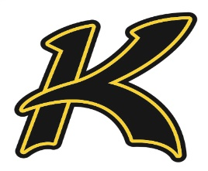
Kress Kangaroo’s
2020 Varsity Baseball Schedule
Date Opponent Location Time
February 11th Spring lake-Earth Kress 4:00 pm (scrimmage)
February 18th Spring lake-Earth SLE 5:00 pm
February 25th Lockney Lockney 4:30 pm
February 27th- February 29th SLE Tournament SLE TBA
March 5th- March 7th Crosbyton Tournament Crosbyton TBA
March 13th
March 20th *Clarendon Clarendon
March 27th *Nazareth Kress
March 31st *Memphis Memphis
April 3rd *Claude Claude
April 7th *Shamrock Kress
April 10th *Valley Valley
April 14th *Nazareth Nazareth
April 17th *Wellington Kress
April 21st *Claude Kress
April 24th *Shamrock Shamrock
April 28th *Valley Kress
*District game
Head Coach: Shawn Langston Principal: Phil Zolman
AD: Mark Earhart Superintendent: Leah Zeigler

