Day | Date | Opponent | Place | Time
Friday | 1/25/19 | First Day of Practice | EHHS | 4:00 PM
Friday  Tuesday | 2/1/19  2/5/19 | Inter-Squad (S)  Bryan Adams (S) | EHHS  BAHS | 4:00 PM  4:00 PM
Friday  Saturday | 2/8/19  2/9/18 | Dallas Kimball (S)  Covenant Christian (S) | EHHS  EHHS | 5:30 PM  1:00 PM
Tuesday | 2/12/19 | Dunbar (S) | DHS | 6:00 PM
Friday | 2/15/19 | Pinkston (S) | EHHS | 6:00 PM
Th/Fr/Sa | 2/21-23/19 | Bryan Adams (T) | TBA | TBA
Th/Fr/Sa | 2/28/19-3/2/19 | Eastern Hills (T) | TBA | TBA
Th/Fr/Sa | 3/7-9/19 | Skyline (T) | TBA | TBA
Tuesday  Wednesday | 3/12/19  3/13/19 | South Hills (D)  South Hills (D) | EHHS  SHHS | 1:00 PM  11:00 AM
Tuesday | 3/19/19 | Carter Riverside (D) | CRHS | 7:00 PM
Friday | 3/22/19 | Carter Riverside (D) | EHHS | 7:00 PM
Tuesday | 3/26/19 | North Side (D) | NSHS | 7:00 PM
Friday | 3/29/19 | North Side (D) | EHHS | 7:00 PM
Tuesday | 4/2/19 | Arlington Heights (D) | EHHS | 7:00 PM
Friday | 4/5/189 | Arlington Heights (D) | AHHS | 7:00 PM
Tuesday | 4/9/19 | OD Wyatt (D) | ODHS | 7:00 PM
Friday  Tuesday  Thursday  Tuesday  Friday | 4/12/19  4/16/19  4/18/19  4/23/19  4/26/19 | OD Wyatt (D)  Poly (D)  Poly (D)  Southwest (D)  Southwest (D)(*) | EHHS  EHHS  PHS  SWHS  EHHS | 7:00 PM  7:00 PM  7:00 PM  7:00 PM  7:00 PM
 |  | Scrimmage (S)  Tournament: (T)  Non-District: (ND)  District: (D)  Senior Night: (*) |  | 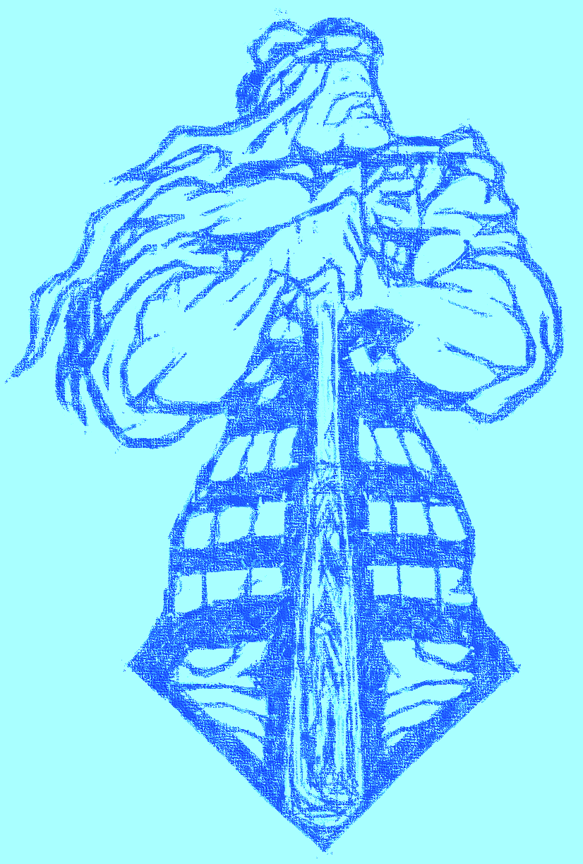
Head Coach: Bryan Naradovy
Varsity Assistant: Blake Parker
Athletic Director: Lisa Langston
Athletic Coordinator: Tracy Simien
Head Principal: Katrina Smith
Trainers: Jason Moore, Morgan Pope

