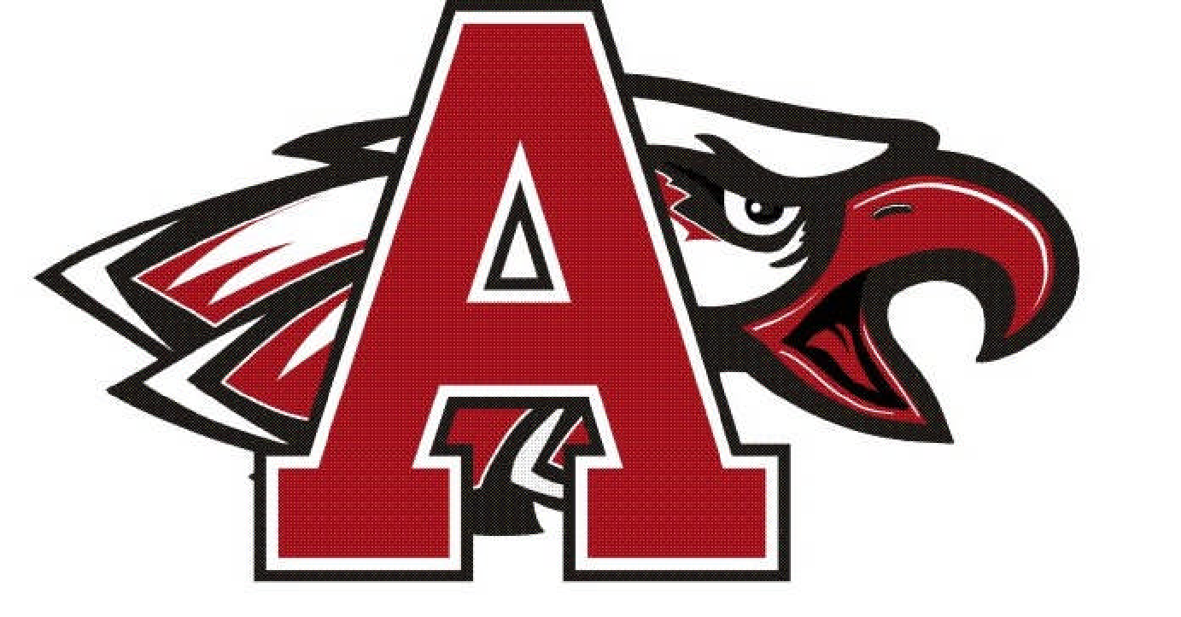

Argyle Eagle Baseball
2020 Varsity Schedule

Mon Feb. 10 AUBREY (Scrimmage) 4:30 ARGYLE
Sat Feb. 15 FRISCO/JESUIT (Scrimmage) 11:00/3:00 ARGYLE
Tue Feb. 18 Little Elm (Scrimmage) 5:00 ARGYLE
Sat Feb. 22 Mineral Wells (Scrimmage) 2:00 Mineral Wells
Th Feb. 27 Princeton Varsity Tournament T B A Princeton
Fri Feb. 28 Princeton Varsity Tournament T B A Princeton
Sat Feb. 29 Princeton Varsity Tournament T B A Princeton
Th March 5 Collin County Varsity Tournament T B A T B A
Fri March 6 Collin County Varsity Tournament T B A T B A
Sat March 7 Collin County Varsity Tournament T B A T B A
Th March 12 Melissa Varsity Tournament T B A Melissa
Fri March 13 Melissa Varsity Tournament T B A Melissa
Sat March 14 Melissa Varsity Tournament T B A Melissa
Tue March 17 TBA
Sat March 21 CELINA 2:00 ARGYLE
Tue March 24 Benbrook 7:00 Benbrook
Sat March 28 CRANDALL 2:00 ARGYLE
Fri April 3 Decatur 7:30 Decatur
Sat April 4 PROM
Tue April 7 Bridgeport 7:30 Bridgeport
Th April 9 SPRINGTOWN 7:30 ARGYLE
Tue April 14 Krum 7:30 Krum
Sat April 18 Denton Guyer 11:00 ARGYLE
Tue April 21 DECATUR 7:30 ARGYLE
Fri April 24 BRIDGEPORT 7:30 ARGYLE
Sat April 25 HILLCREST 2:00 ARGYLE
Tue April 28 Springtown 7:30 Springtown
Fri May 1 KRUM 7:30 ARGYLE

Head Coach -- Ricky Griffin Superintendent – Dr. Telena Wright
Asst. Coach -- Steve Stinson Principal – John King
Asst. Coach -- Jake Fischer Athletic Dir. –Todd Rodgers
Asst. Coach – Storm Griffin Trainers – Aaron Fowler, Eddie Vega and
Caitlyn Theaker

