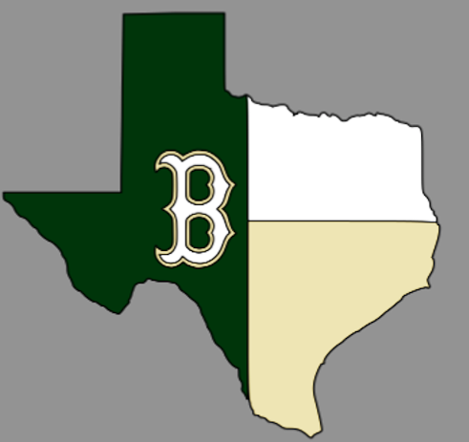
LYFORD VARSITY BASEBALL
SCHEDULE 2020

DATE | OPPONENT | TIME&PLACE
FEBRUARY 11 | RAYMONDVILLE  (SCRIMMAGE) | 7 PM AWAY
FEBRUARY 14 | BROWNSVILLE PACE  (SCRIMMAGE) | 6 PM HOME
FEBRUARY 17 | BROWNSVILLE ST. JOE  (SCRIMMAGE) | 6 PM HOME
FEBRUARY 21 | HIDALGO  (SCRIMMAGE) | 6 PM HOME
FEBRUARY 24 | PORT ISABEL | 7 PM HOME
FEBRUARY 27 - 29 | BISHOP TOURNAMENT | TBA AWAY
MARCH 2 | RIO HONDO | 6:30 PM AWAY
MARCH 5 - 6 | SHARYLAND TOURNAMENT | TBA AWAY
MARCH 10 | SHARYLAND | 6:30 PM AWAY
MARCH 13 | RAYMONDVILLE | 7:30 PM AWAY
MARCH 18 | HEBBRONVILLE | 11 AM AWAY
MARCH 24 | SANTA GERTRUDIS ACADEMY | 6 PM HOME
MARCH 27 | PREMONT | 7 PM AWAY
MARCH 31 | HARMONY* | 5:30 PM AWAY
APRIL 3 | JUBILEE* | 6 PM HOME
APRIL 6 | MONTE ALTO* | 6 PM AWAY
APRIL 9 | IDEA QUEST* | 6 PM HOME
APRIL 14 | SANTA ROSA* | 6 PM AWAY
APRIL 17 | HARMONY*  (LITTLE BULLDOG NIGHT) | 6 PM HOME
APRIL 21 | JUBILEE* | 5:30 PM AWAY
APRIL 24 | MONTE ALTO* | 6 PM HOME
APRIL 28 | IDEA QUEST* | 6 PM AWAY
MAY 1 | SANTA ROSA*  (PARENTS NIGHT) | 6 PM HOME

HEAD COACH:
JOSE ROCHA
ASSISTANTS:
LUIS RODRIGUEZ
GERALD HOLMES

SUPERINTENDENT:
DR. KRISTIN BROWN
ATHLETIC DIRECTOR:
ISRAEL GONZALEZ
PRINCIPAL:
MICHELLE DeWITT

