VARSITY BASEBALL SCHEDULE
2022 Varsity Baseball

DATE | DAY | Home | Away | LOCATION | TIME
*February 5, 2022 | Saturday | SOC | Thomas Jefferson | Higgins | 12:00pm
*February 5, 2022 | Saturday | TRYA Classic | TRYA Classic | Oates Field | 3:30pm
*February 7, 2022 | Monday | SOC | F.W. Diamond Hill | Higgins | 7:00pm
*February 11, 2022 | Friday | Desoto | SOC | Desoto | 6:00pm
*February 12, 2022 | Saturday | Pinkston | SOC | Pinkston | 12:00pm
*February 15, 2022 | Tuesday | SOC | O.D. Wyatt | Higgins | 4:30pm
*February 18, 2022 | Friday | SOC | Bishop Dunne | Higgins | 4:30pm
^February 22, 2022 | Tuesday | SOC | Carter | Higgins | 7:00pm
^ February 24-26,2022 | Thursday-Saturday | Gary T. Balch Classic Tournament | F.W. Castleberry | F.W. Castleberry | 9:00am
^March3-5, 2022 | Thursday-Saturday | F. W. Carter-Riverside Varsity Tournament | F. W. Carter-Riverside | F. W. Carter-Riverside | 9:00am
March 8, 2022 | Tuesday | SOC | Spruce | Higgins/Sprague | 4:30pm
March 11-12 2022 | Thursday-Friday | O.D. Wyatt  Tournament | O.D. Wyatt  Tournament | Fort Worth | 9:00am
March 15, 2022 | Tuesday | Molina | SOC | Molina | 1:00pm
March 18, 2022 | Friday | SOC | Samuell | Higgins/Sprague | 1:00pm
March 22, 2022 | Tuesday | Lancaster | SOC | Lancaster | 7:00pm
March 25, 2022 | Friday | SOC | Sunset | Higgins/Sprague | 6:00pm
March 26, 2022 | Saturday | Kimball | SOC | Higgins/Sprague | 1:00pm
March 29, 2022 | Tuesday | SOC | Seagoville | Higgins/Sprague | 4:30pm
April 1, 2022 | Friday | Adamson | SOC | Adamson | 4:30pm
April 5, 2022 | Tuesday | Spruce | SOC | Spruce | 4:30pm
April 8, 2022 | Friday | BYE | BYE | BYE | BYE
April 12, 2022 | Tuesday | SOC | Molina | Higgins/Sprague | 4:30pm
April 15, 2022 | Friday | Samuell | SOC | Samuell | 4:30pm
April 19, 2022 | Tuesday | SOC | Lancaster | Higgins/Sprague | 7:00pm
April 22, 2022 | Friday | Sunset | SOC | Sunset | 4:30pm
April 23, 2022 | Saturday | SOC | Kimball | Higgins/Sprague | 1:00pm
April 26, 2022 | Tuesday | Seagoville | SOC | Seagoville | 4:30pm
April 29, 2022 | Friday | SOC | Adamson | SOC | 4:30pm
* Scrimmages/^ Non-District Games/ District Games in BOLD
Mascot: Golden Bears
Colors: Old Gold & White
District: 12-5A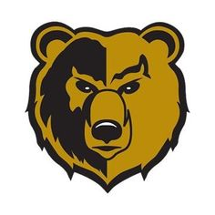
SOUTH OAKCLIFF HIGH SCHOOL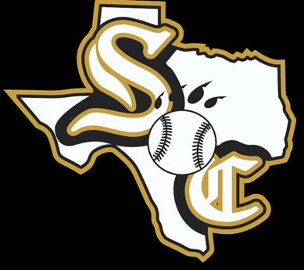

Head Coach: Marlon J. Reaves Assistant Coach:
Athletic Coordinator: James C. Mays III Assistant Athletic Coordinator: Jason Todd
Principal: Dr. Willie F. Johnson Assistant Athletic Director/Baseball: Bryan Barnett
Superintendent: Dr. Michael Hinojosa Athletic Trainer: Jocelyn Shackelford
DISD Athletic Director: Dr. Silvia Salinas

