2021 Blanco Baseball Schedule
Date | Opponent |  |  | Site | Teams | Time
Feb 6 | Luling (Scrimmage) |  |  | Luling | Varsity | 1:00
Feb 9 | TMI (Scrimmage) |  |  | Blanco | Varsity | 6:00
Feb 9 | Harper (Scrimmage) |  |  | 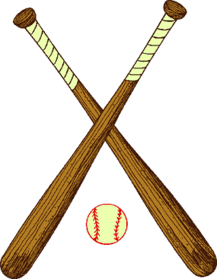  Blanco | JV | 4:00
Feb 17 | Brackenridge (Scrimmage) |  |  | San Antonio | JV/Varsity | 4:30
Feb 20 | Alumni (Scrimmage) |  |  | Blanco | JV/Varsity | 1/5:00
Feb 22 | Johnson City |  |  | Blanco | JV/Varsity | 4:30/7
Feb 25-27 | Marion Tournament |  |  | Marion | Varsity | TBA
March 2 | SA Feast |  |  | Blanco | JV/Varsity | 4:30/7
March 4-6 | Llano Tournament |  |  | Llano | Varsity | TBA
March 4-6 | Wimberley |  |  | Wimberley | JV | TBA
March 9 | SA Feast |  |  | Blanco | Varsity | 5:00
March 9 | Geneva |  |  | Geneva (DH) | JV | 3:30
March 11-13 | Blanco Tournament |  |  | Blanco | Varsity | TBA
March 23 | Cuero |  |  | Cuero | JV/Varsity | 4:30/7
March 26 | SA Cole |  |  | Blanco | Varsity | 6:00
March 29 | *Llano |  |  | Llano | JV/Varsity | 4:30/7
April 1 | *Lago Vista |  |  | Blanco | JV/Varsity | 4:30/7
April 5 | *Ingram |  |  | Ingram | Varsity | 6:00
April 9 | *Comfort |  |  | Blanco | JV/Varsity | 4:30/7
April 16 | *Llano |  |  | Blanco | JV/Varsity | 4:30/7
April 17 | Marion Tournament |  |  | Marion | JV | TBA
April 20 | *Lago Vista |  |  | Lago Vista | JV/Varsity | 4:30/7
April 27 | *Ingram |  |  | Blanco | JV/Varsity | 4:30/7
April 30 | *Comfort |  |  | Comfort | JV/Varsity | 4:30/7

