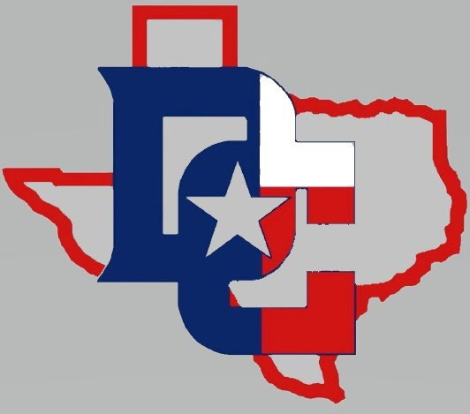**Denver City**

**Mustangs Baseball 2025**

**(Subject to Change) 1/8/25**

**Date Day Opponent Site Varsity JV**

Feb. 3 Mon. Abernathy (Scrimmage) Denver City 4:00

Feb. 10 Mon. Littlefield (Scrimmage) Littlefield 4:30

Feb. 17 Mon. Seminole Denver City 4:30 6:30

Feb. 20 - 22 Thurs. – Sat. Abernathy JV Tourn. Abernathy TBA

Feb. 20 – 22 Thurs. – Sat. Shallowater Tourn. Shallowater TBA

Feb. 27 – 28 Thurs. – Fri. Denver City Tourn. Denver City TBA

Feb. 27 – 28 Thurs. – Fri. ECISD JV Tourn. Odessa TBA

Mar. 4 Tues. NMMI Denver City 4:00 -6:00

Mar. 8 Sat. Odessa Compass Denver City 12:00

Mar. 11 Tues. Crane Crane 7:00 4:30

Mar. 15 Sat. Stanton Denver City 12:00 2:30

Mar. 18 Tues. Coahoma Coahoma 7:00 4:30

Mar. 22 Sat. Lamesa Denver City 12:00 2:30

Mar. 25 Tues. Brownfield Denver City 4:30 7:00

Mar. 29 Sat. Roswell High Denver City 1:30

Apr. 1 Tues. Odessa Compass Denver City 5:00

Apr. 5 Sat. Crane Denver City 12:00 2:30

Apr. 8 Tues. Stanton Stanton 7:00 4:30

Apr. 12 Sat. Coahoma Denver City 12:00 2:30

Apr. 15 Tues. Lamesa Lamesa 7:00 4:30

Apr. 22 Tues. Brownfield Brownfield 7:00 4:30

Head Coach: Robert Arreola Assistants: Luis Rodriguez, Mark Herrera

Athletic Director: Doug Duncan